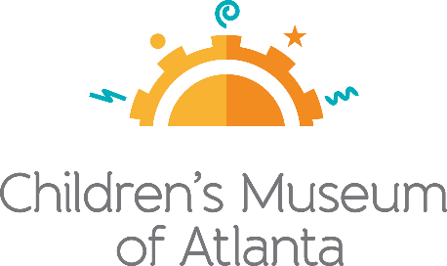

Thank you for your interest in Run! Jump! Fly! Adventures in Action™, kicking off the New Year at Children’s Museum of Atlanta, January 19-May 27, 2019. We kindly request that anyone interested in attending media week (taking place January 19-25) complete the enclosed media credentials ticket request for consideration.

Please complete the below application and return to bmeyer@emailbrave.com before January 10. Requests will be confirmed based on level of coverage, with priority given to outlets providing significant advance feature coverage. Confirmed media will receive up to 4 tickets and be notified by email no later than Tuesday, January 15.

For more information, please contact:
Becca Meyer
BRAVE Public Relations
404.233.3993
bmeyer@emailbrave.com

Run! Jump! Fly! Adventures in Action Press Ticket Request

January 19-25, 2019
MEDIA APPLICATION
Application deadline: January 10, 2019
Media credentials are not transferrable.

CONTACT INFORMATION

Name
Title
Outlet
Phone
Email

PLEASE ONLY COMPLETE THE SECTION
THAT APPLIES TO YOUR MEDIA OUTLET

PRINT

Primary Publication/Outlet:

Form (please circle or highlight): |  | Newspaper |  |  |  |  | Magazine
Frequency (please circle or highlight): Daily |  |  | Weekly |  | Bi-Weekly |  | Monthly |  | Quarterly | Other
Distribution (please circle or highlight): |  | Local |  |  | Regional |  | National |  | International
Circulation:
TV
Distribution (please circle or highlight): |  | Local |  | Regional |  | National |  | International

Call Letters:
Network:
Program Name:

RADIO

Distribution (please circle or highlight): Local Regional National International

Program Name:

ONLINE/BLOG

URL:
Monthly hits:
Editor/Producer:
Telephone:
Additional Publication/Outlet:
Market:

TYPE OF COVERAGE

**Briefly Describe Stories and Length of Coverage for Run! Jump! Fly! Adventures in Action!**
Run Date:

DO YOU PLAN ON POSTING TO SOCIAL MEDIA? YES NO

**If so, please detail the medium(s) you plan to post on and their followings**

INTERVIEW REQUESTS - FOR CHILDREN’S MUSEUM OF ATLNATA REPRESENTATIVES

AS A CONDITION OF RECEIVING PRESS TICKETS TO RUN! JUMP! FLY! ADVENTURES IN ACTION, I AGREE TO SEND TEAR SHEETS OR A COPY OF MY COVERAGE AS SOON AS IT BECOMES AVAILABLE. AS A REMINDER, PRIORITY TICKETS WIL BE GIVEN TO OUTLETS GIVING ADVANCE COVERAGE.

Applicant’s Signature: ___________________________________
Date: __________________________

PLEASE RETURN THIS FORM BY January 10, 2019

Send to:

BRAVE Public Relations

Attention: Becca Meyer

Email: bmeyer@emailbrave.com

